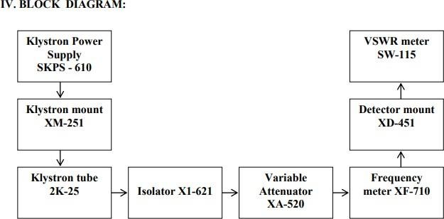

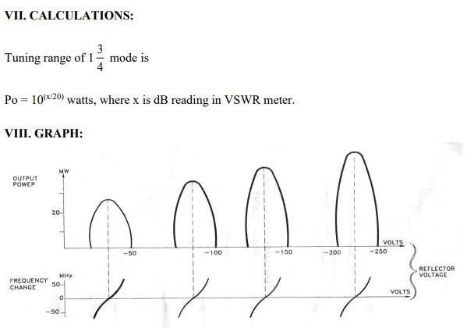**TABULATION**

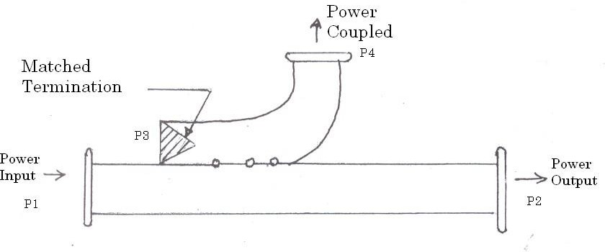

**Figure 1: Directional coupler as a three – port device: Uni directional coupler**

# BLOCK DIAGRAM

**Mode 3 setup:**

Insertion Loss (V12) measurement

Insertion Loss (V12) measurement

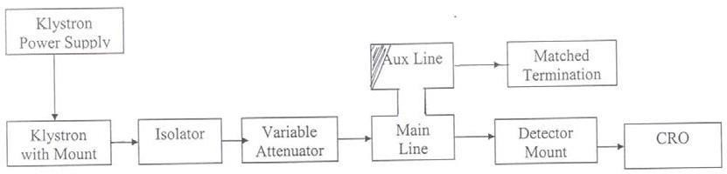

Coupling Factor (V14) measurement

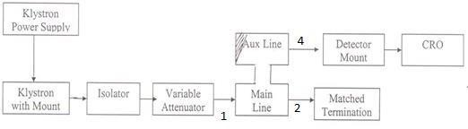

**TABULATION**

# DIRECTIVITY MEASUREMENT

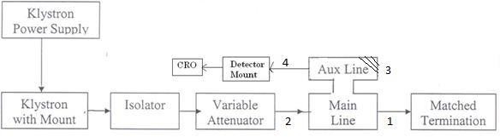

# BLOCK DIARGAM

**Characteristics of E & H Plane Tee**

Klystron Power Supply

Isolator

Klystron with Motor

Variable attenuator

E/H Tee

Detector Mount

|  |  |  |
| --- | --- | --- |
| Matched  Termination |  | |
|  | CRO |
|  |

# TABULATION:

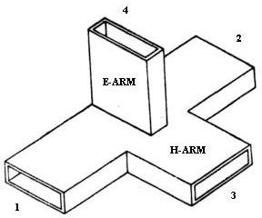**E-Plane Tee H- Plane Tee**

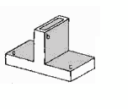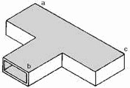

**Characteristics of Magic Tee**

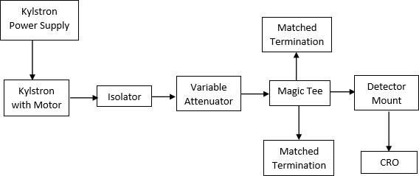

**Magic Tee**

**TABULATION**

**Calculation of Impedance using Smith Chart**

1. Determine VSWR of the given load from the measurement
2. Draw a VSWR Circle
3. Calculate the shift l in terms of wavelength.
4. Locate the shift point from (0,0) moving clockwise (if l is negative) or anticlockwise (if l is positive) on the circumference.
5. Join the point to the centre of smith chart.
6. The intersection of VSWR circle and the line gives the normalized load impedence (ZL)

**Theoretical Calculations:**

Load impedance **(ZL)** is calculated from the product of normalized impedance and characteristic impedance of slotted line.

# FORMULA

**FORMULA:**

**Characteristics Impedance Z0**

Z0   -(fc/f0))2

*ZL* = zo



1- *j* (*VSWR*) tan l

*VSWR* -*j* tan l

l = (X-Y) / g

Fc  Cutoff frequency

Fc = c/c

c  Cut off wavelength

c = 2a

A  inner broad dimension of waveguide

g = 2(d1  d2) VSWR = Vmax/Vmin

**BLOCK DIAGRAM IMPEDANCE MEASUREMENT**

Movable

short/ Load



**CRO**

Tunable probe

Slotted Section with Probe Carriage

Variable Attenuator

Frequency Meter

Klystron with Mount

Isolator

Klystron Power Supply

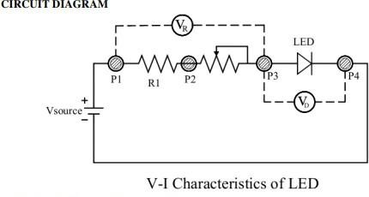

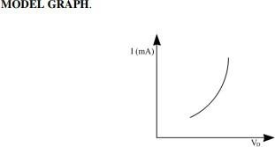

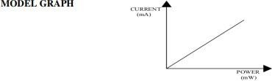

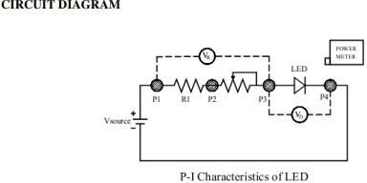

**TABULATION**

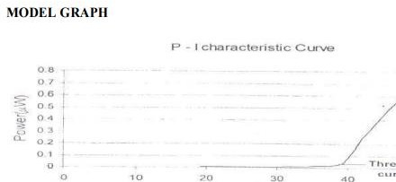

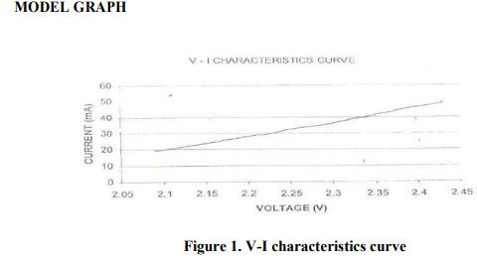

**TABULATION**

**Photo detector setup**

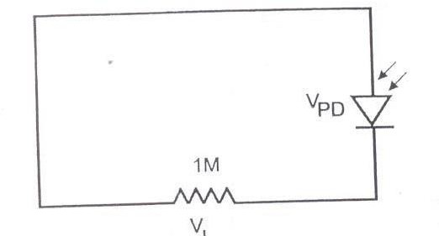

**Figure 1: PD with zero bias configuration**

# TABULATION

**MODEL GRAPH**

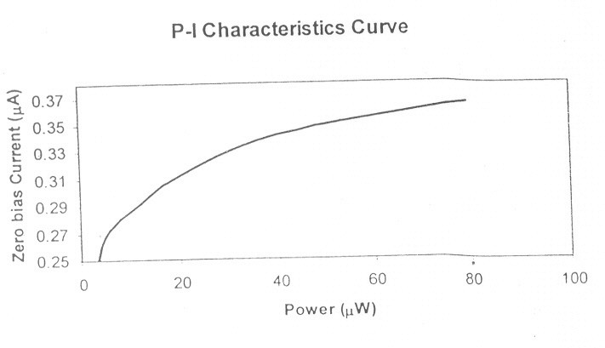

**Figure 2 Power Vs Current graph**

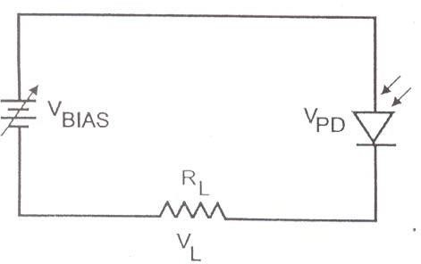

**Figure 3: PD with forward bias configuration**

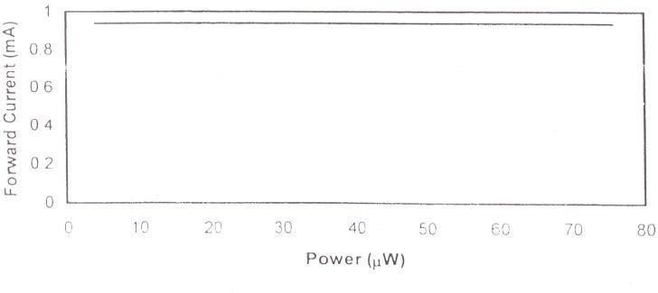

**Figure 4 Power Vs Current graph**

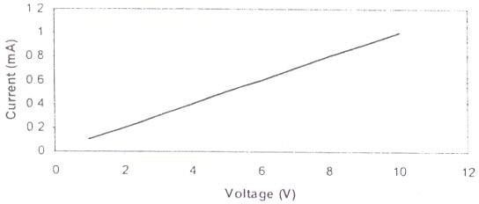

**Fig. 5 Voltage Vs. Current graph**

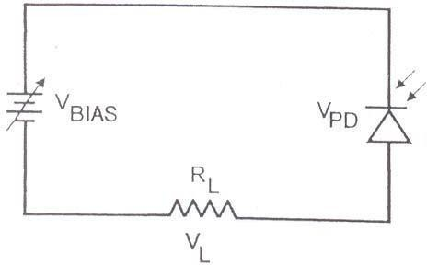

**Figure 6: PD with reverse bias configuration**

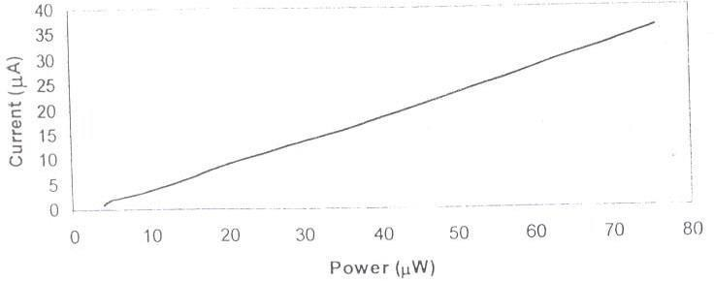

**Figure 7: Power Vs Current graph**

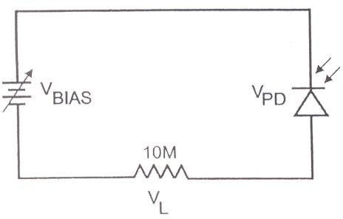

**Figure 8: PD with leakage characteristics**

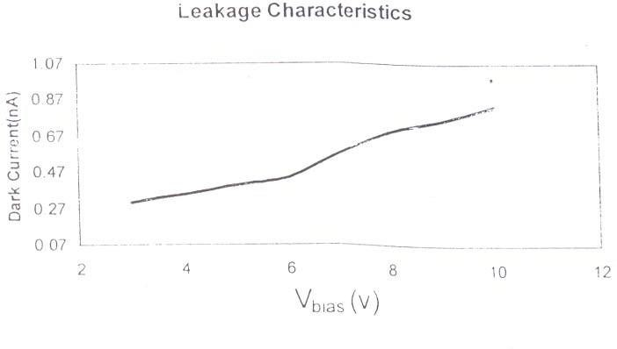

**Figure 9. Voltage Vs Dark Current graph**

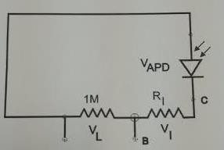

**Figure 1: APD with zero bias configuration**

# TABULATION

* + - 1. 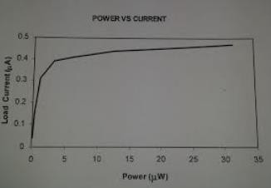**MODEL GRAPH**

**Figure 2 Power Vs Current graph**

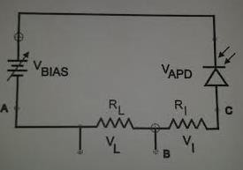

**Figure 3: APD with reverse bias configuration**

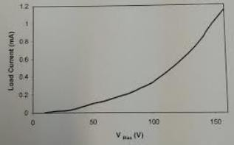

**Figure 4: Bias Voltage Vs Load Current graph**

**Figure 5: APD with leakage characteristics**



VBIAS

VA

10V

# DIAGRAM

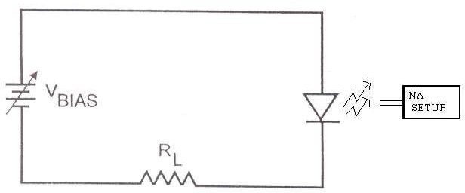

**Figure 1: Numerical aperture setup**

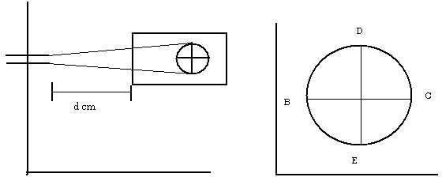

**Figure 2: Numerical aperture**

# TABULATION:

# MODEL GRAPH

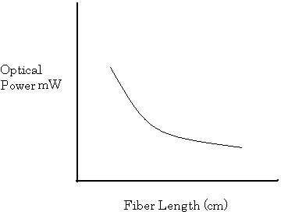

**Figure 1: Optical power vs. Fiber length**

# TABULATION:

# MODEL GRAPH

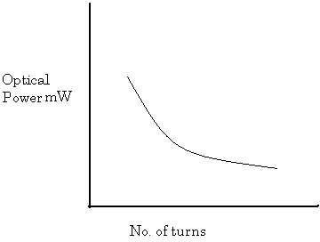

**Figure 1: Optical power vs. No. of turns**

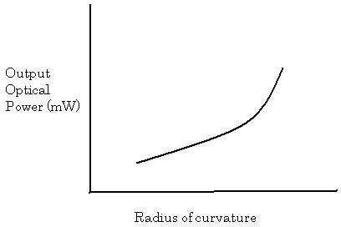

**Figure 2: Optical power vs. Radius of curvature**

# TABULATION:

**Layout**

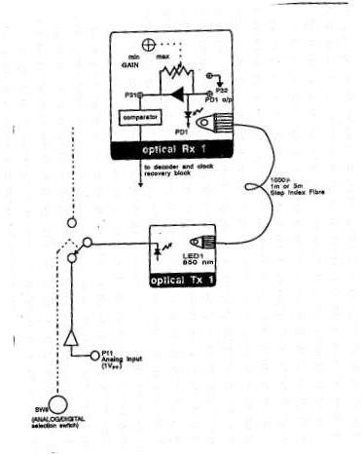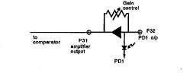

**Figure 1: Gain control**

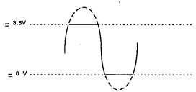

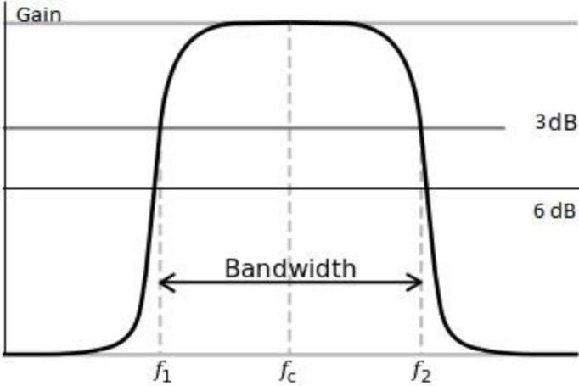

# TABULATION:

**Model Graph**

# LAYOUT DIAGRAM:

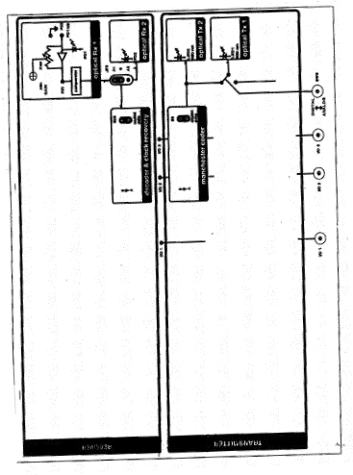

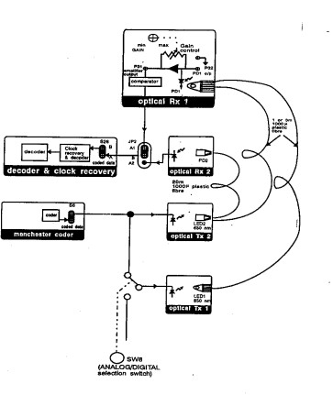

COMPARATOR TO CONVERT RECEIVED SIGNAL INTO A TTL SIGNAL:

